**# Lesson 13**

**Topic:** Introduce time-based calculations.

**Prerequisites:** Download Chocolate Sales.csv file and disable Auto DateTime options by Options in Current File and create new DATE table by using Calendarauto and Format functions.

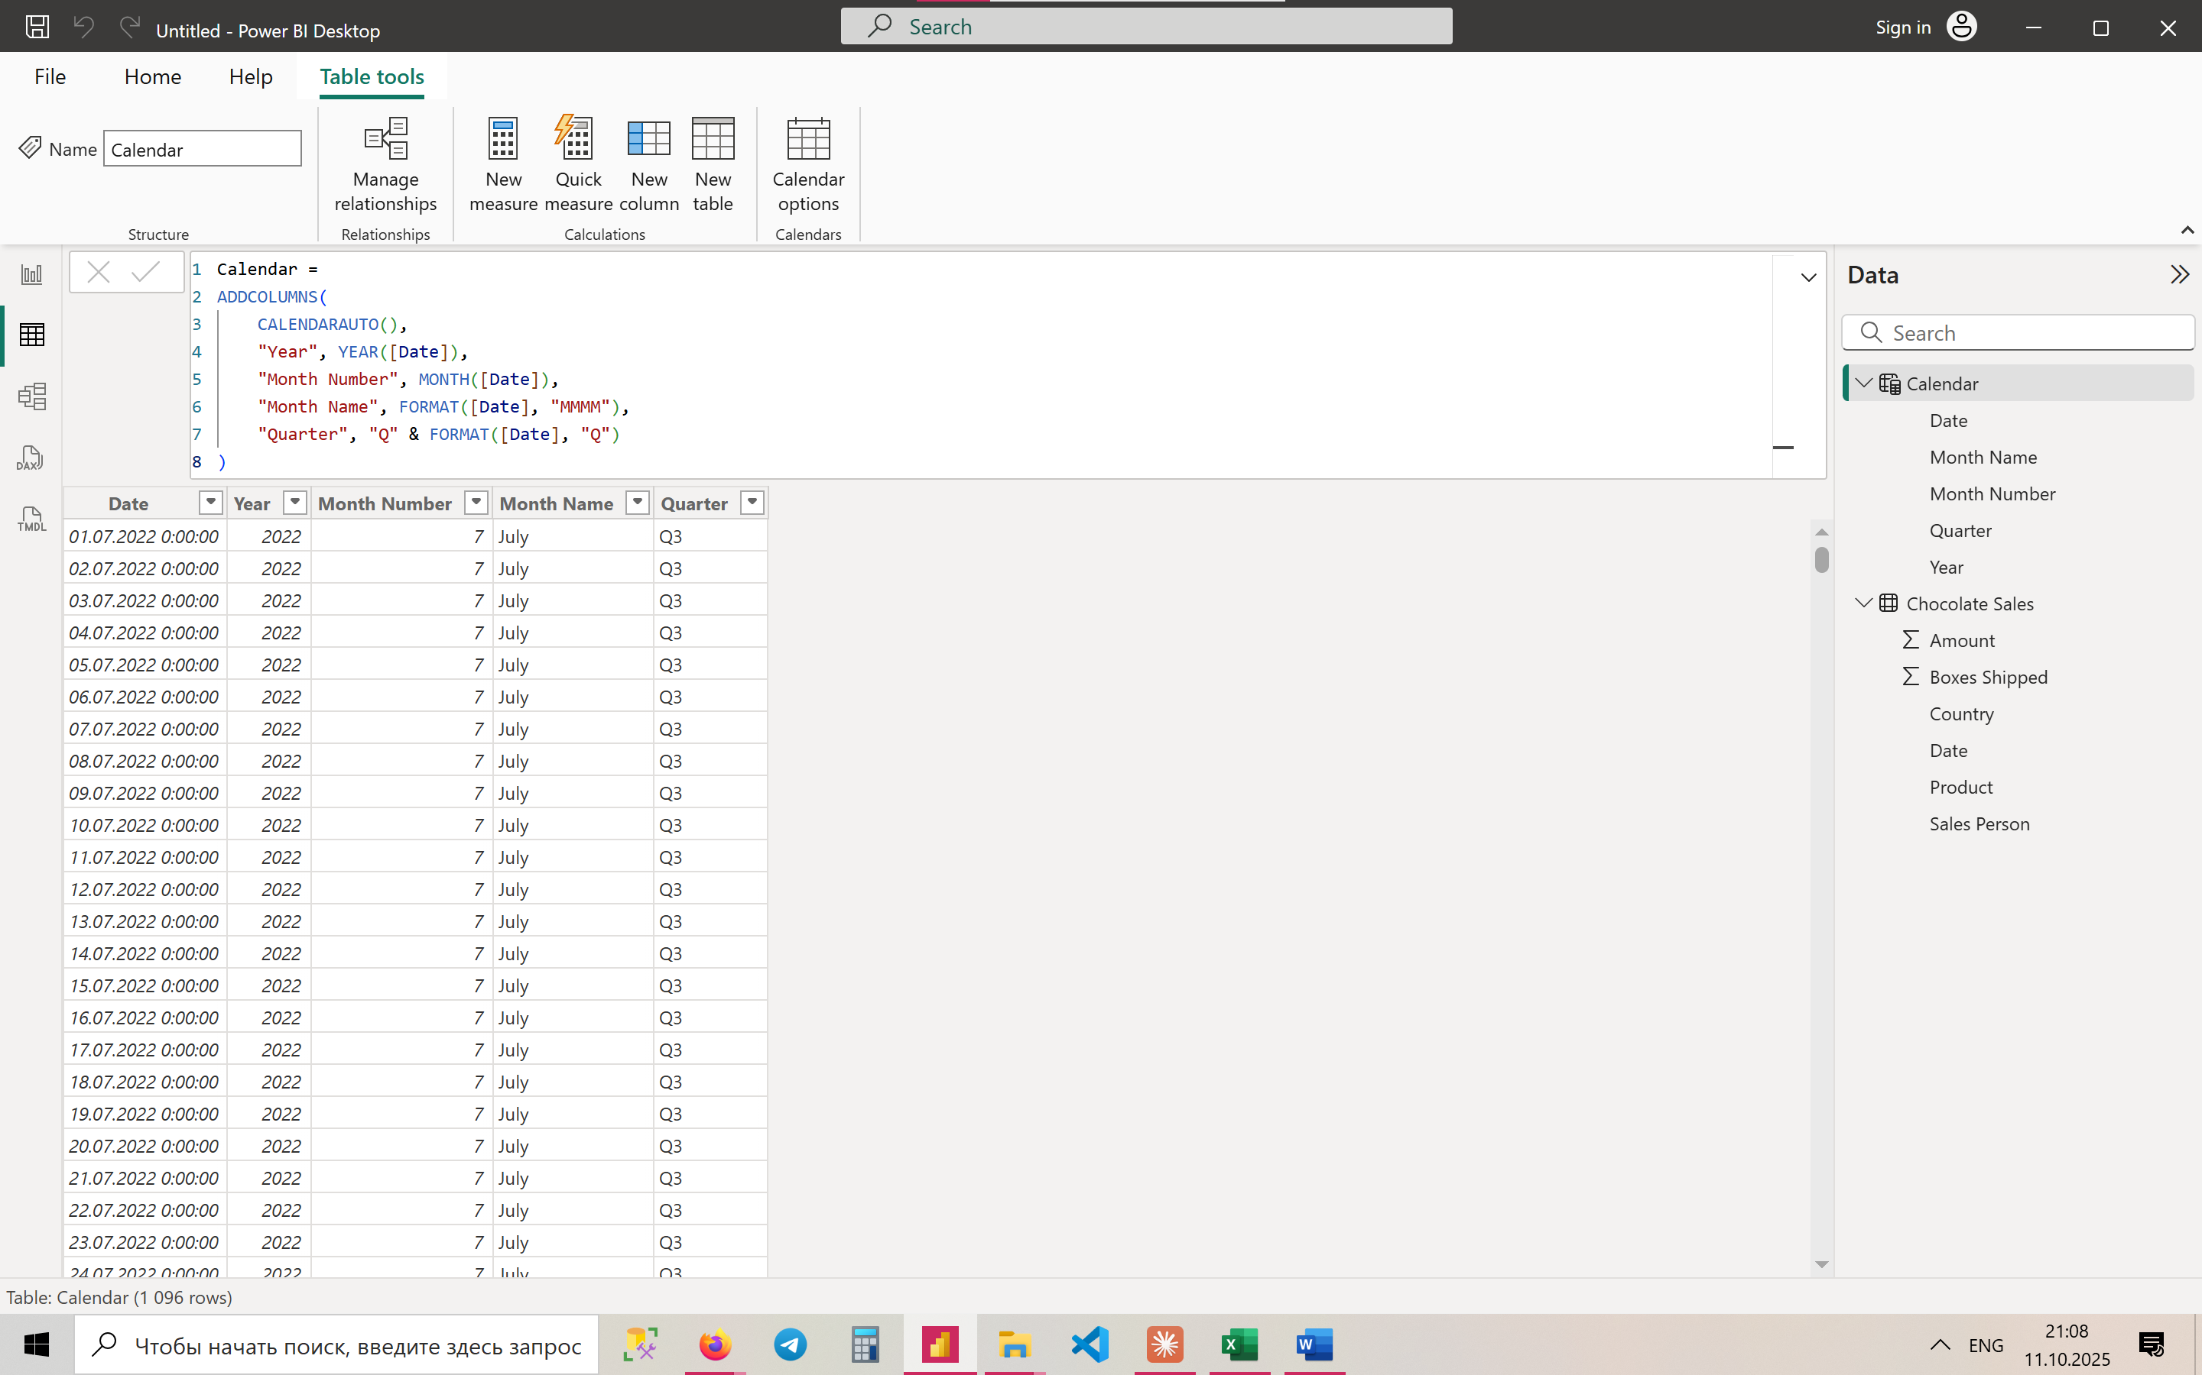

New table – Calendar

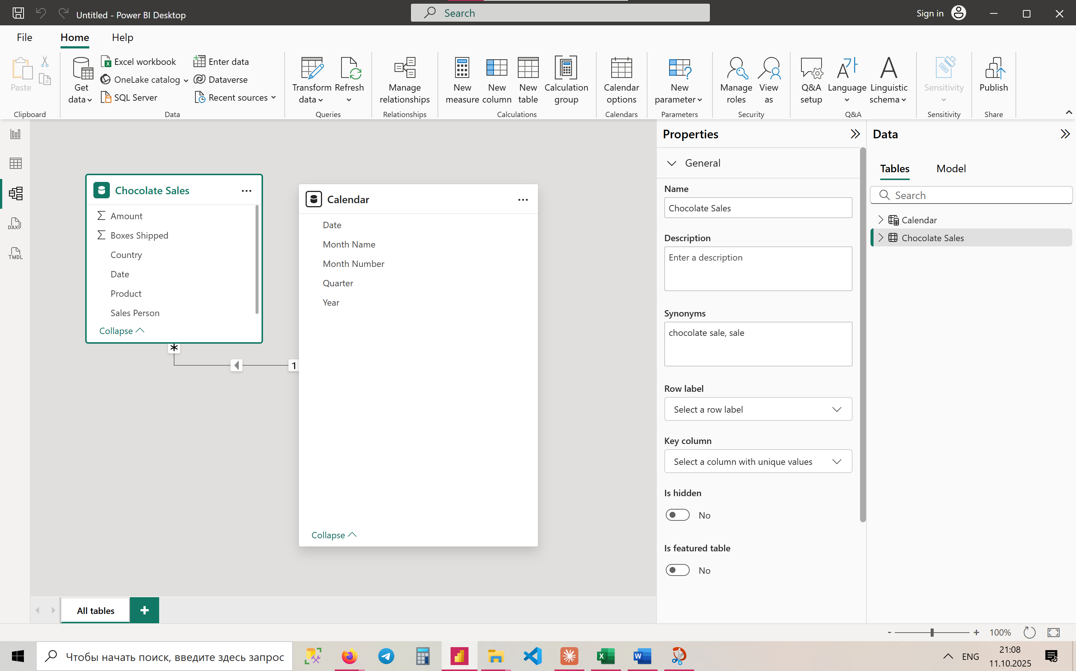

Connection by Date between 2 tables

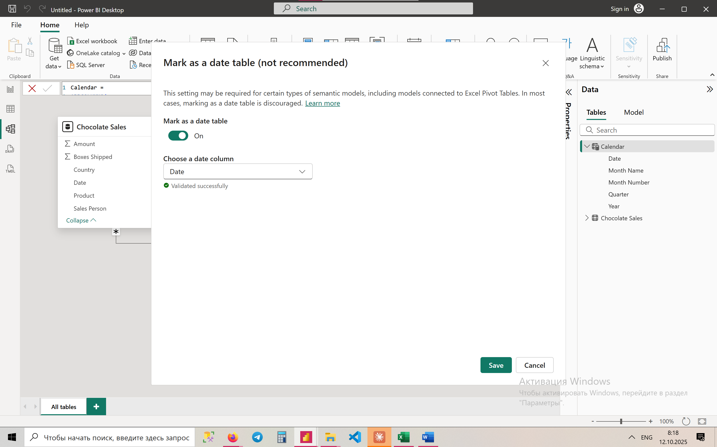

Marking as a date table

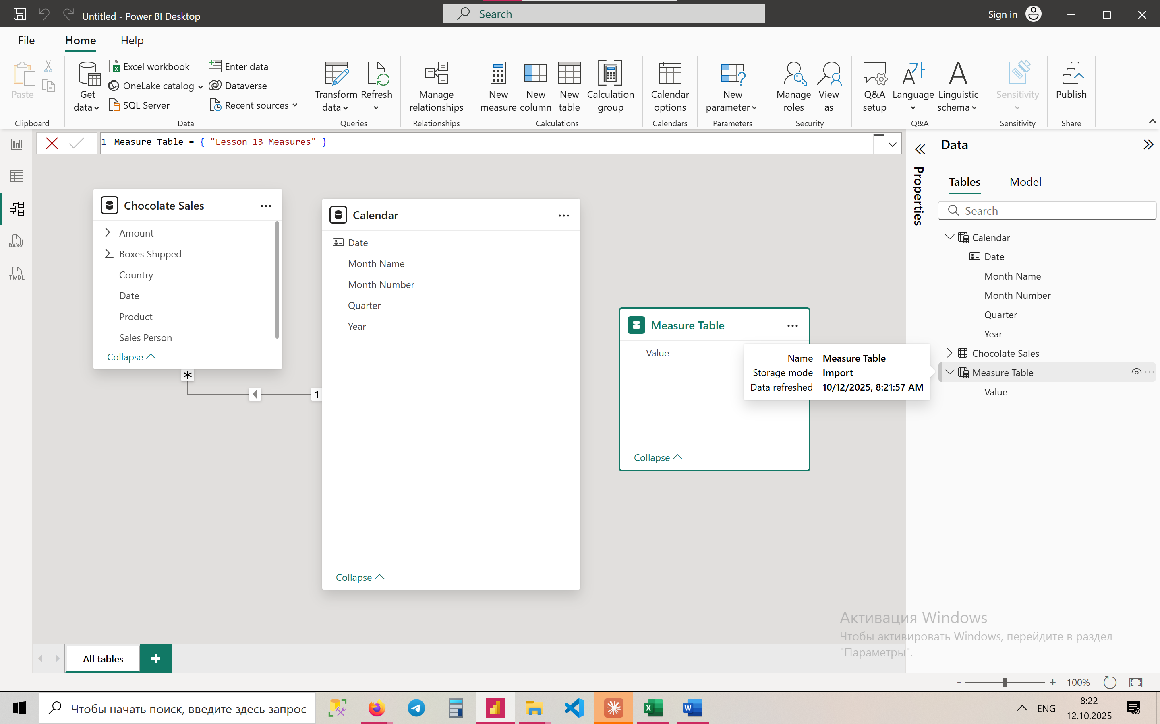

Creating a new table only for measures

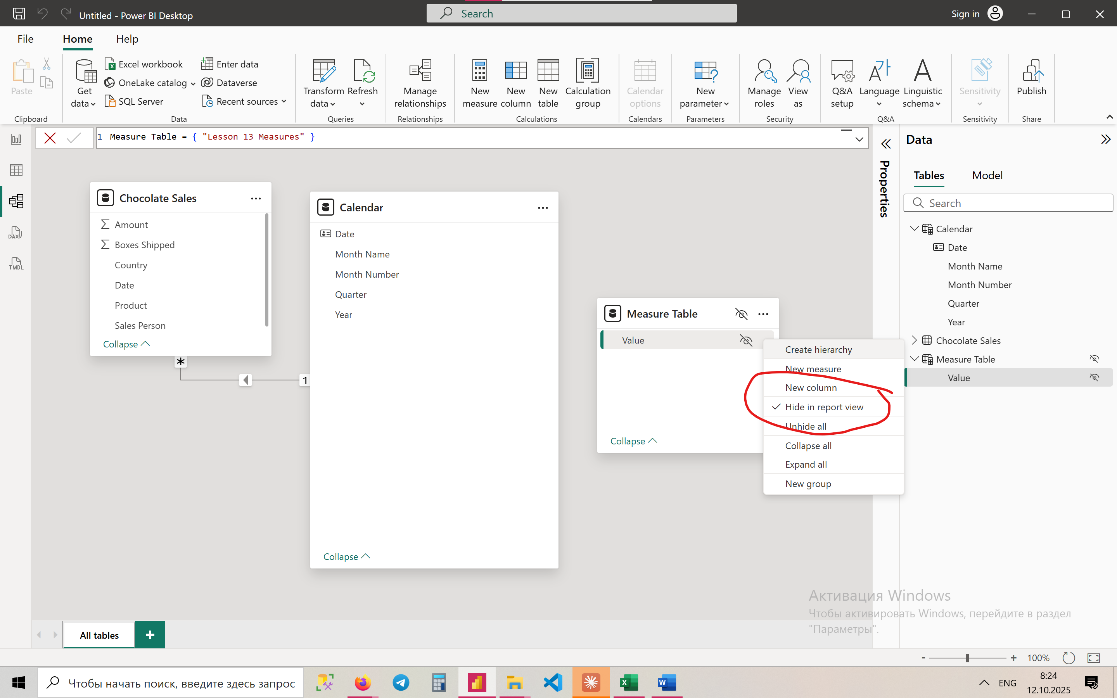

We should hide it

**🟢 BASIC LEVEL (1–5)**

**1 Total Sales**

Total Sales = SUM('Chocolate Sales'[Amount])

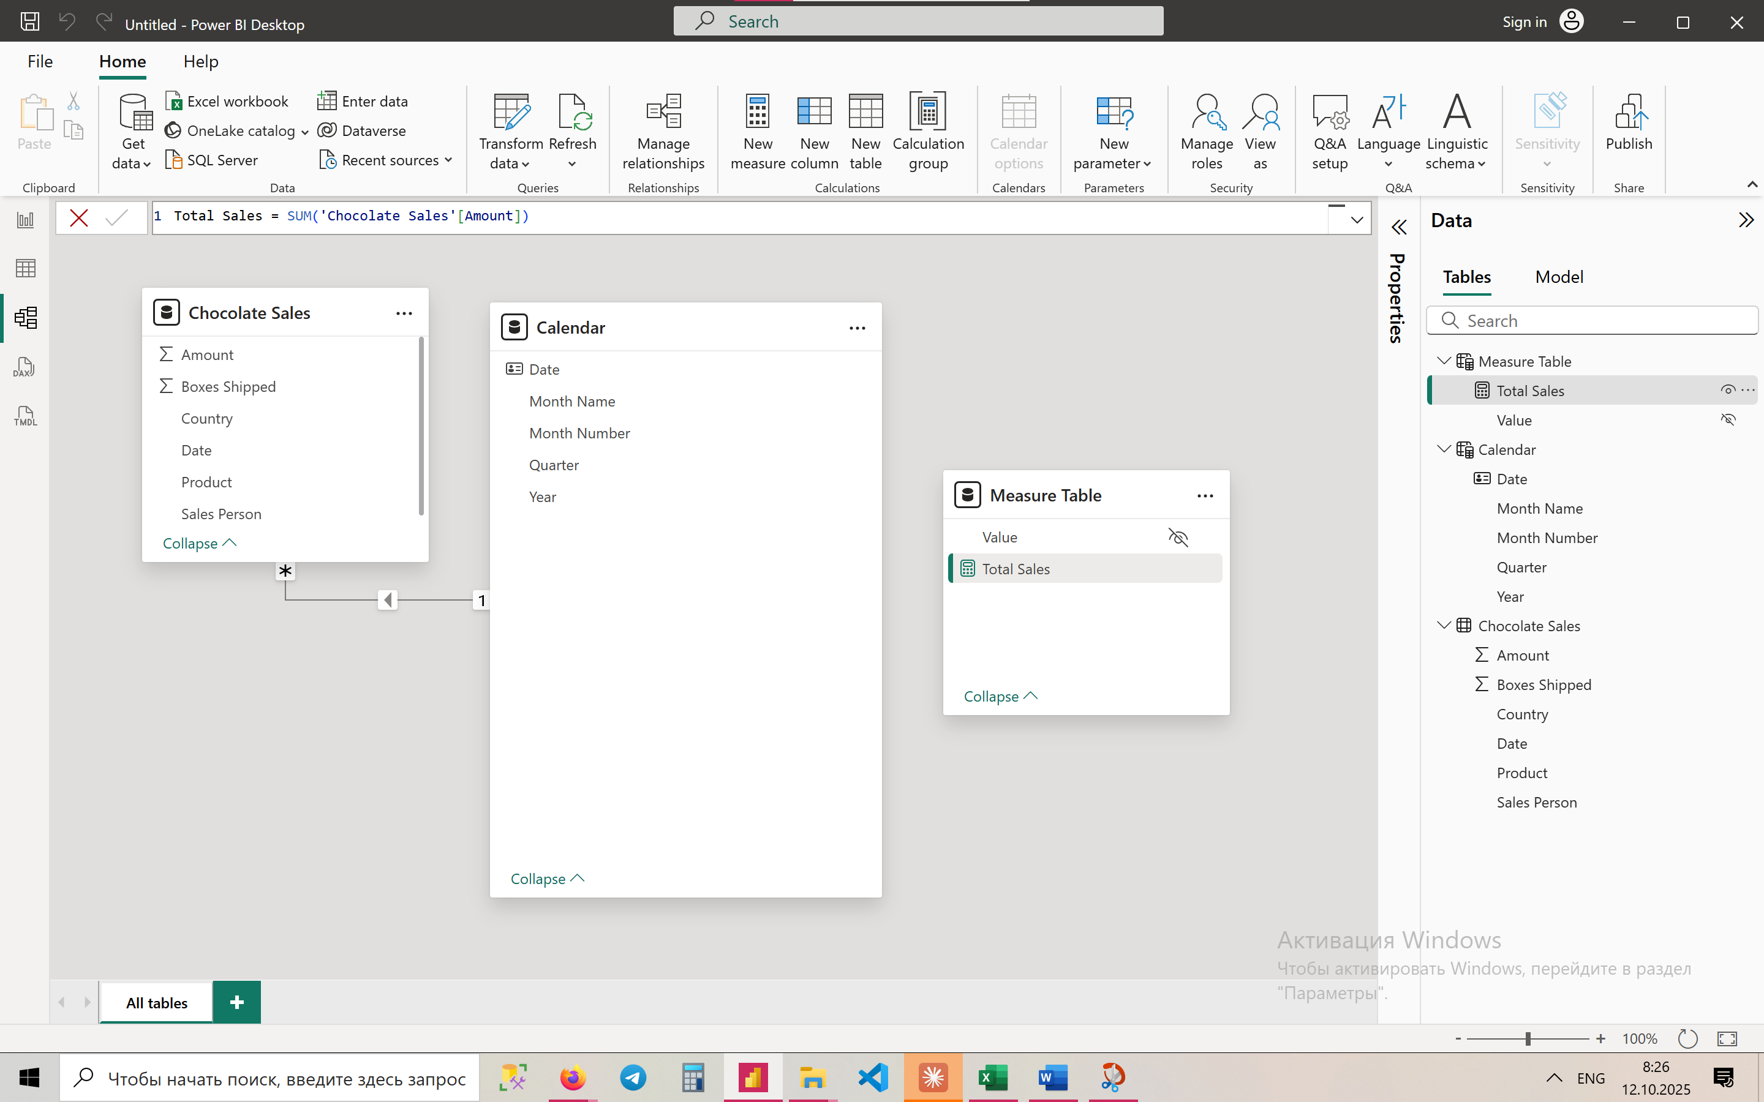

**2. Total Sales — Current Year**

Total Sales Current Year =

CALCULATE(

    [Total Sales],

    FILTER(

        'Calendar',

        YEAR('Calendar'[Date]) = YEAR(TODAY())

    )

)

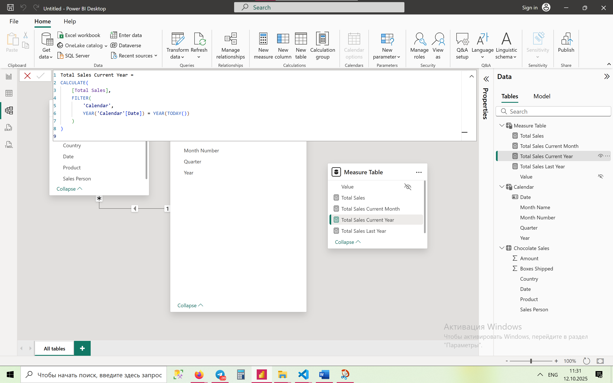

3. **Total Sales — Last Year**

Total Sales Last Year =

CALCULATE(

[Total Sales],

FILTER(

'Calendar',

YEAR('Calendar'[Date]) = YEAR(TODAY()) - 1

)

)

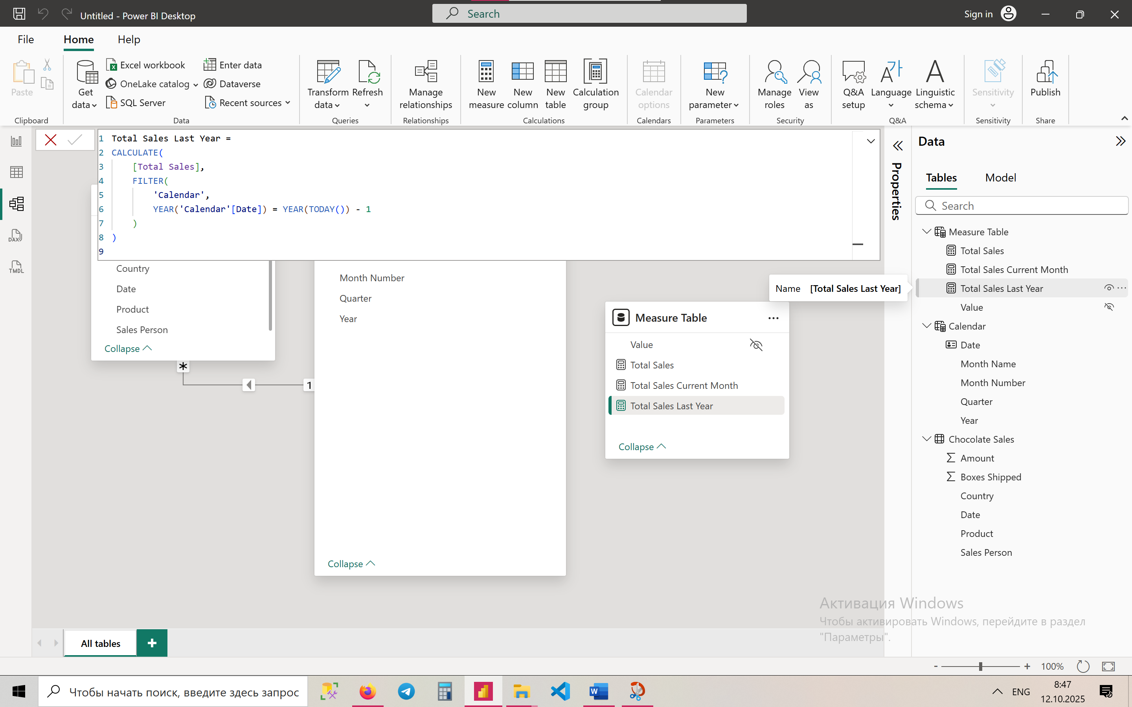

**4. Total Sales — Current Month**

Total Sales Current Month =

VAR MaxDate = MAX('Calendar'[Date])

VAR CurrYear = YEAR(MaxDate)

VAR CurrMonth = MONTH(MaxDate)

RETURN

CALCULATE(

    [Total Sales],

    FILTER(ALL('Calendar'),

        'Calendar'[Year] = CurrYear &&

        'Calendar'[Month Number] = CurrMonth

    )

)

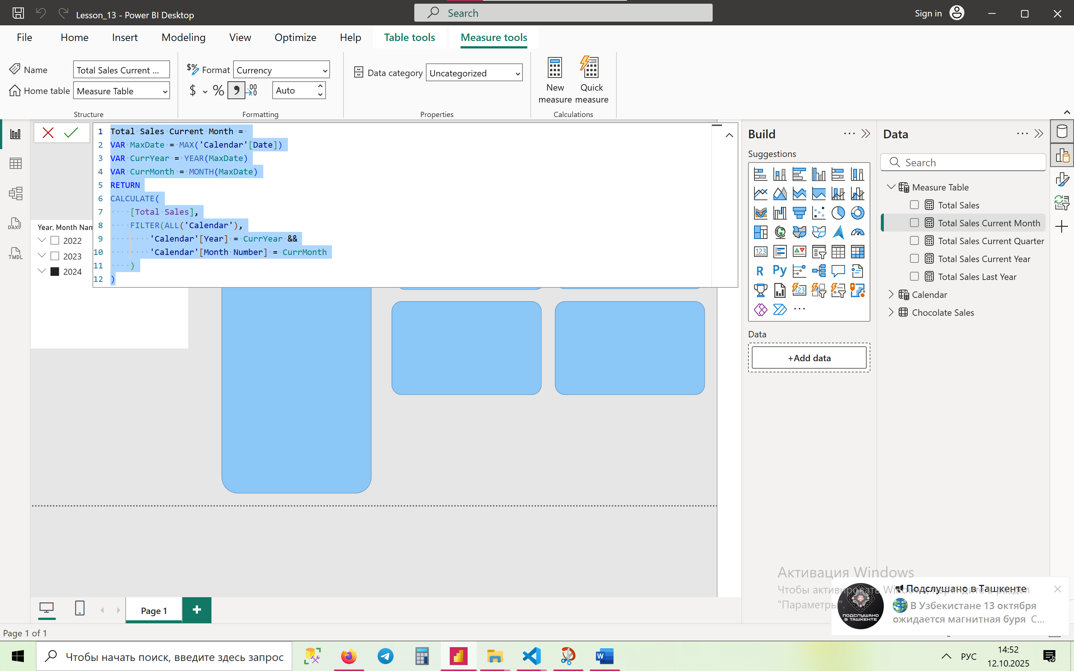

5. Create a measure to calculate total sales for the **current quarter.**

**Total Sales Current Quarter =**

VAR MaxDate = MAX('Calendar'[Date])

VAR CurrYear = YEAR(MaxDate)

VAR CurrQ    = QUARTER(MaxDate)

RETURN

CALCULATE(

    [Total Sales],

    FILTER(

        ALL('Calendar'),

        'Calendar'[Year] = CurrYear &&

        'Calendar'[Quarter] = CurrQ

    )

)

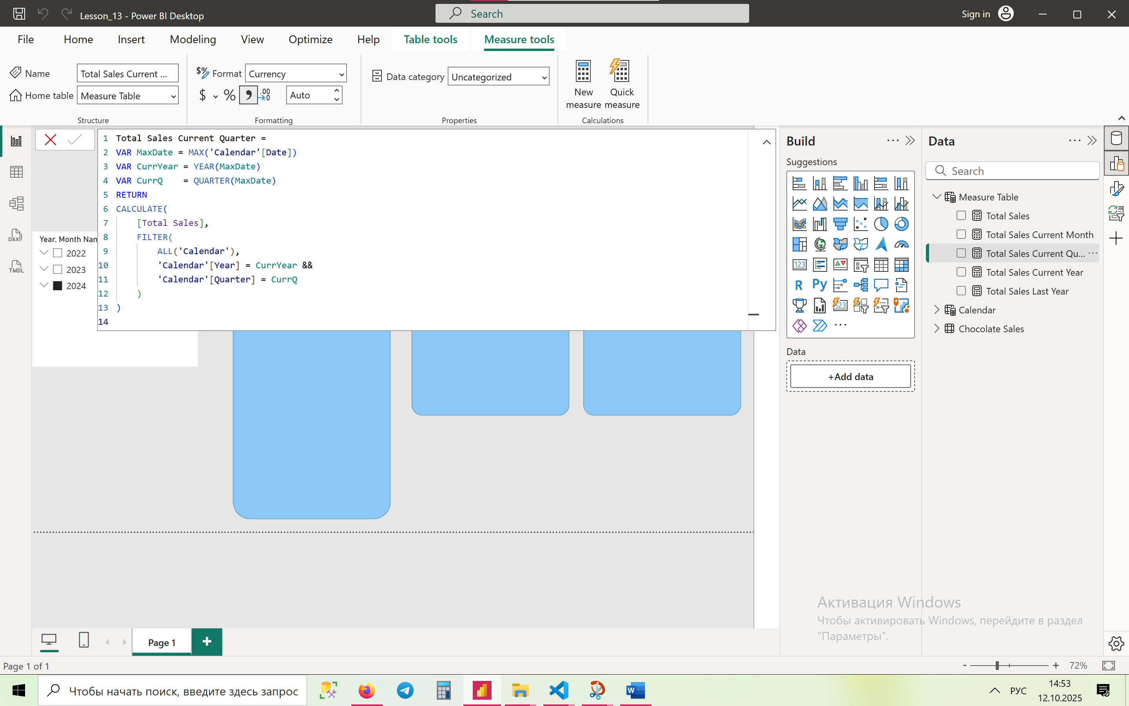

**Intermediate (6–10)**

1. Sales Growth % Compared to Last Year (%YoY)

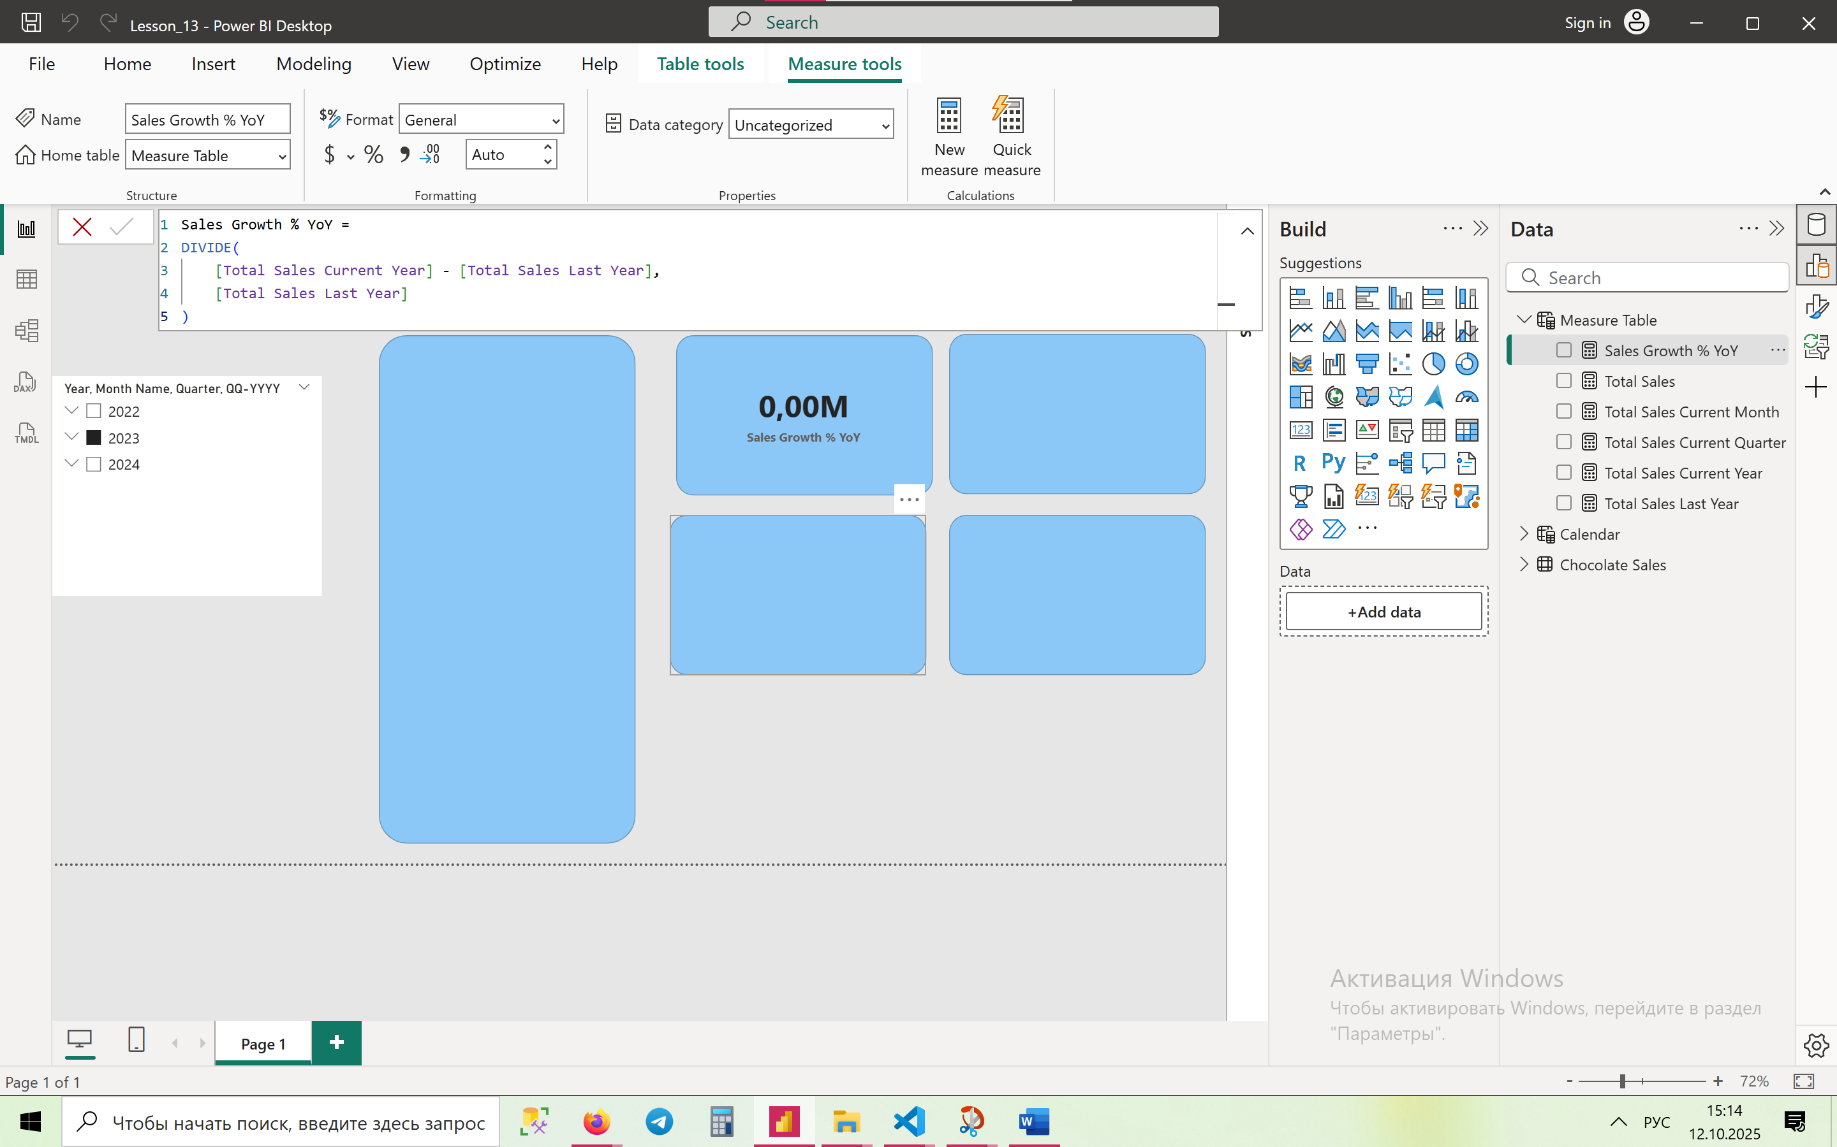

1. Create a measure to calculate to retrieve sales from the last month.  
     
   **Total Sales Last Month =**

VAR MaxDate = MAX('Calendar'[Date])

VAR CurrYear = YEAR(MaxDate)

VAR CurrMonth = MONTH(MaxDate)

VAR PrevMonth = CurrMonth - 1

VAR PrevYear =

IF(PrevMonth = 0, CurrYear - 1, CurrYear)

VAR RealPrevMonth =

IF(PrevMonth = 0, 12, PrevMonth)

RETURN

CALCULATE(

[Total Sales],

FILTER(

ALL('Calendar'),

'Calendar'[Year] = PrevYear &&

'Calendar'[Month Number] = RealPrevMonth

)

)

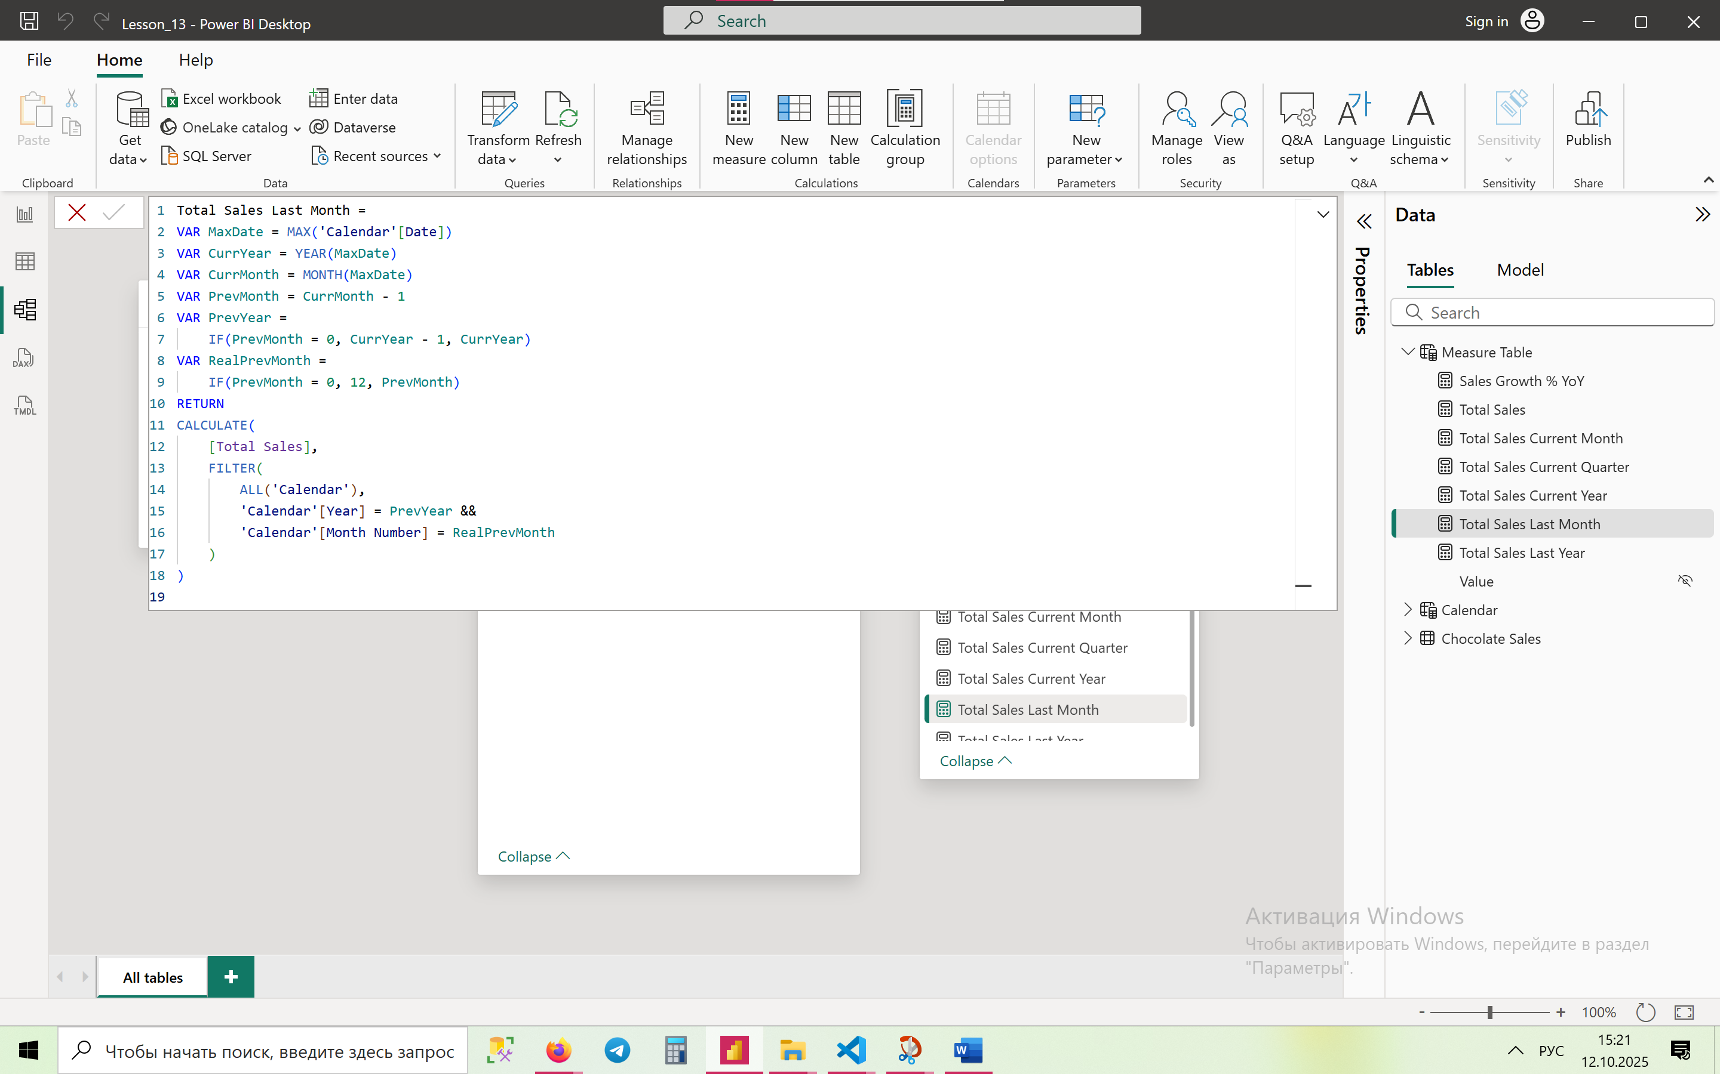

1. Create a measure to calculate a running total of sales using

Running Total Sales =

CALCULATE(

[Total Sales],

FILTER(

ALLSELECTED('Calendar'[Date]),

'Calendar'[Date] <= MAX('Calendar'[Date])

)

)

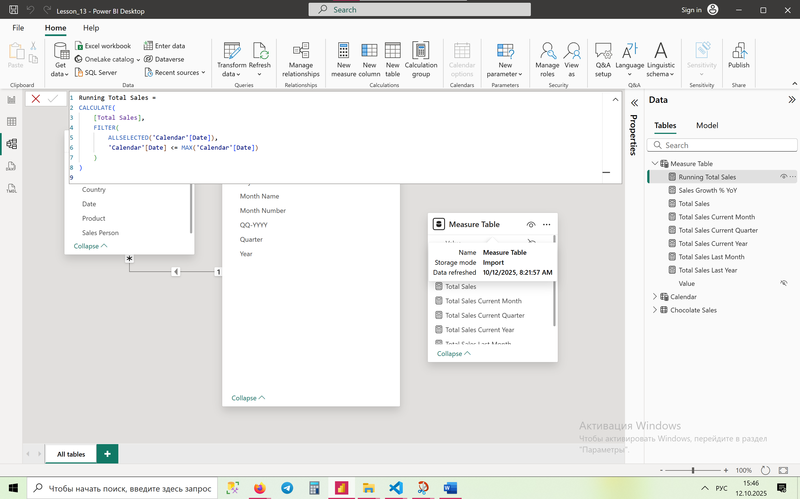

1. Create a measure to compute sales for the last 3 months.

Last 3 Months Sales =

VAR LastVisibleDate = MAX('Calendar'[Date])

RETURN

CALCULATE(

[Total Sales],

FILTER(

ALL('Calendar'),

'Calendar'[Date] <= LastVisibleDate &&

'Calendar'[Date] > EDATE(LastVisibleDate, -3)

)

)

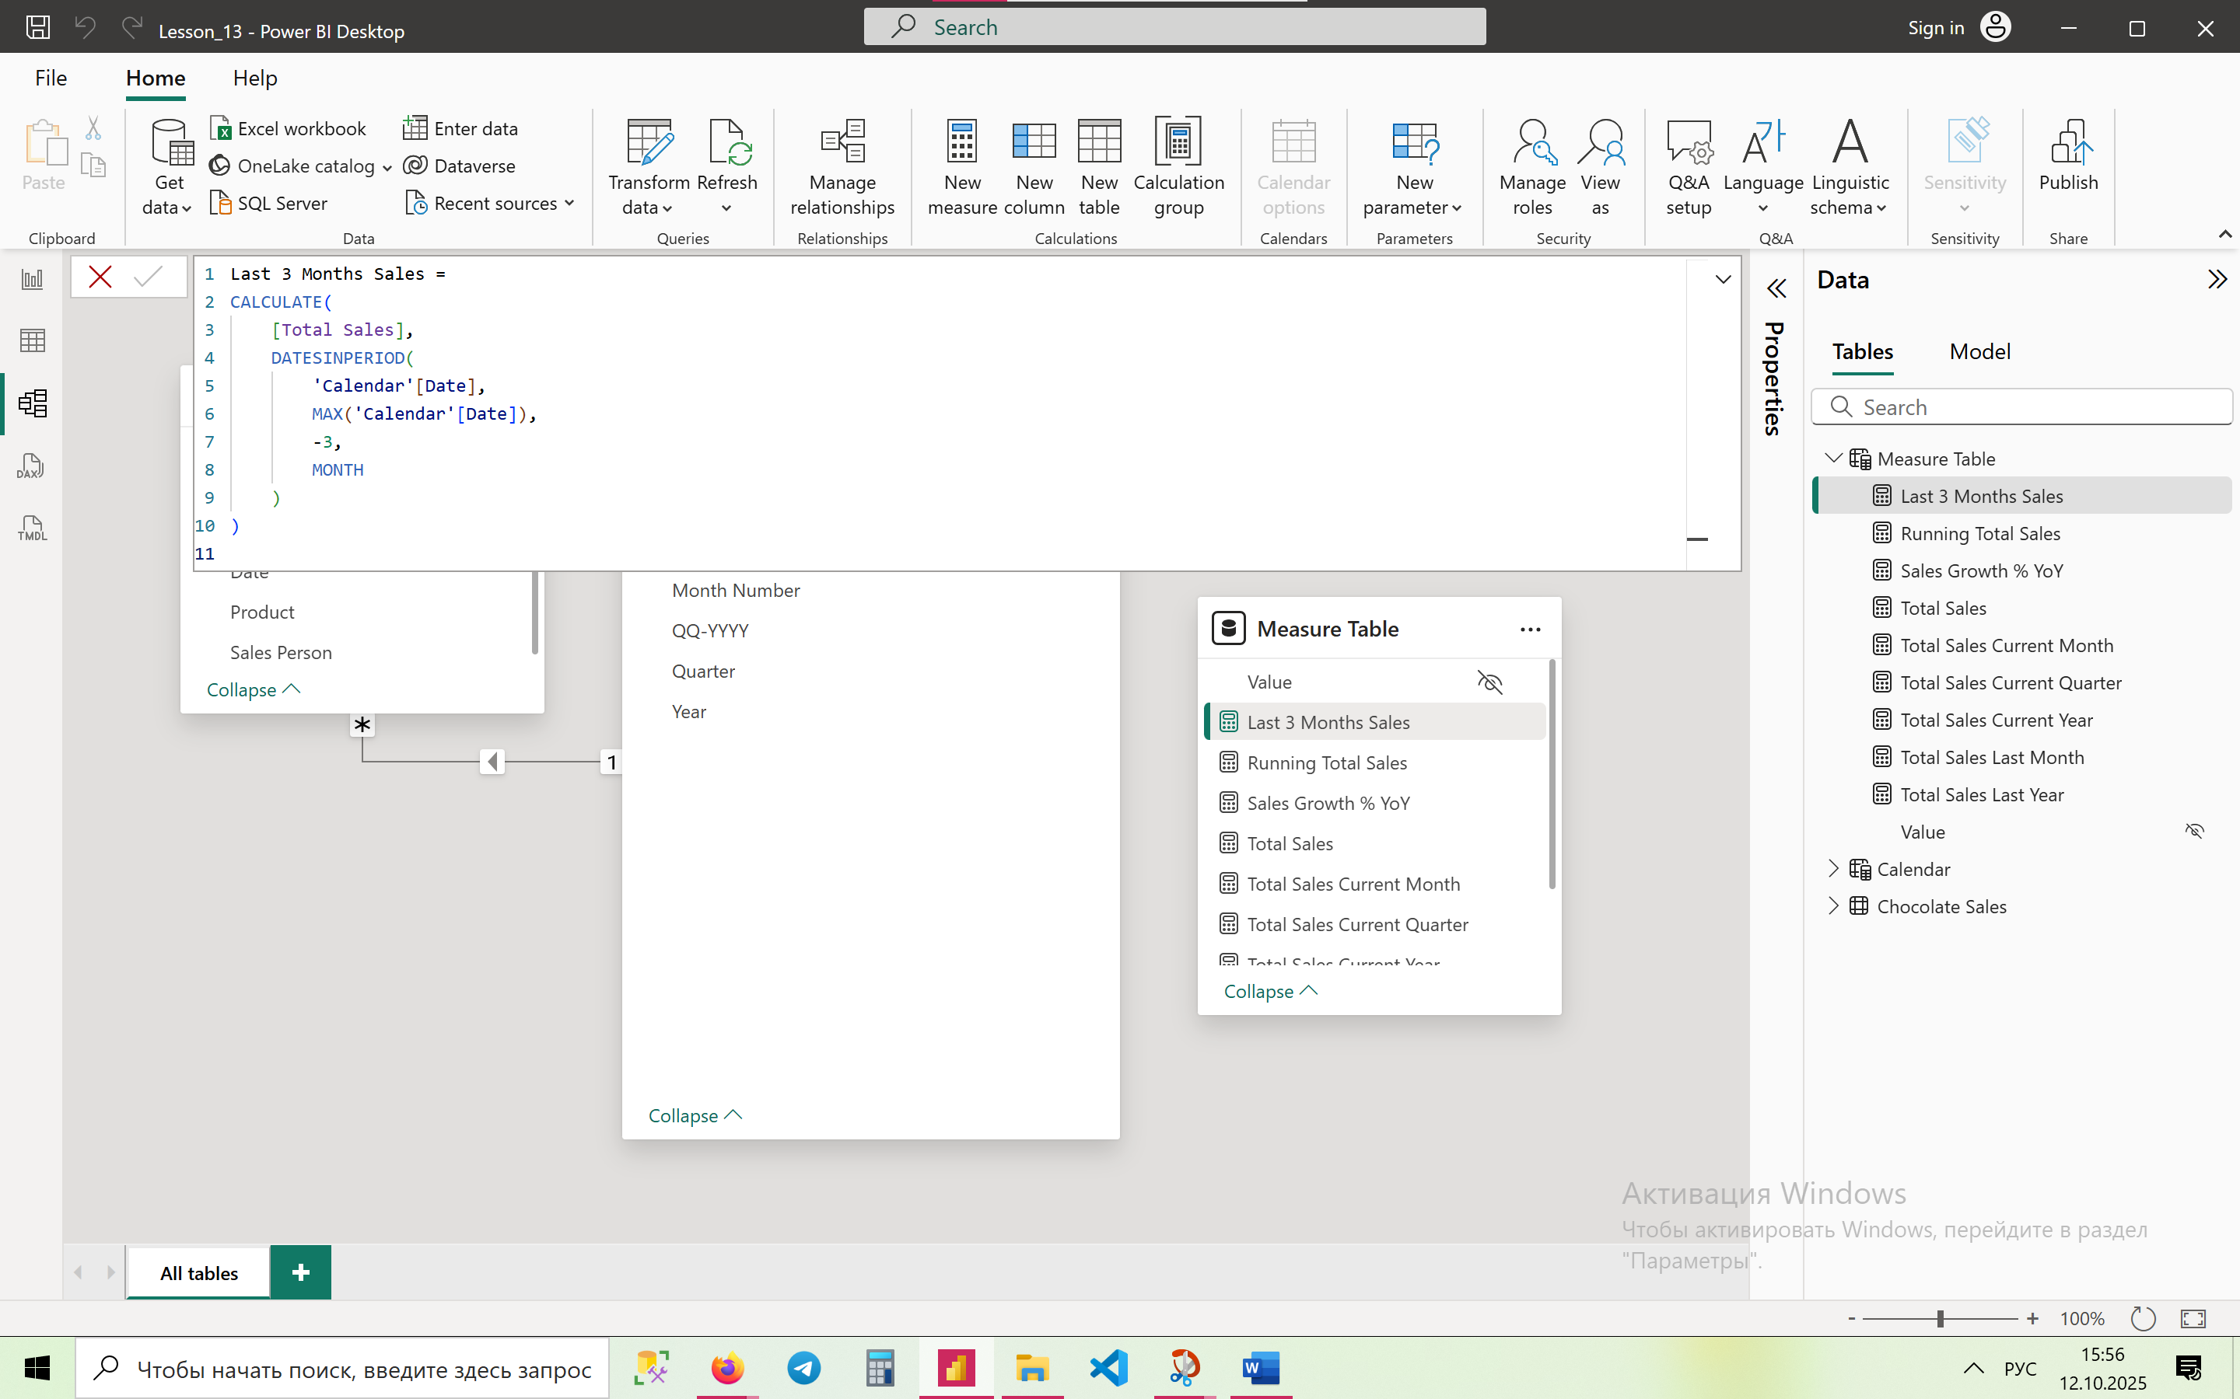

1. Create a measure to identify the month with the highest sales in the previous 12 months.

**Month with Highest Sales (Last 12 Months) =**

VAR LastVisibleDate = MAX('Calendar'[Date])

VAR Last12Months =

DATESINPERIOD('Calendar'[Date], LastVisibleDate, -12, MONTH)

VAR SummaryTable =

ADDCOLUMNS(

SUMMARIZE('Calendar', 'Calendar'[Year], 'Calendar'[Month Name]),

"@Sales", CALCULATE([Total Sales], KEEPFILTERS(Last12Months))

)

VAR TopMonth =

TOPN(1, SummaryTable, [@Sales], DESC)

RETURN

CONCATENATEX(TopMonth, 'Calendar'[Month Name] & " " & 'Calendar'[Year], ", ")

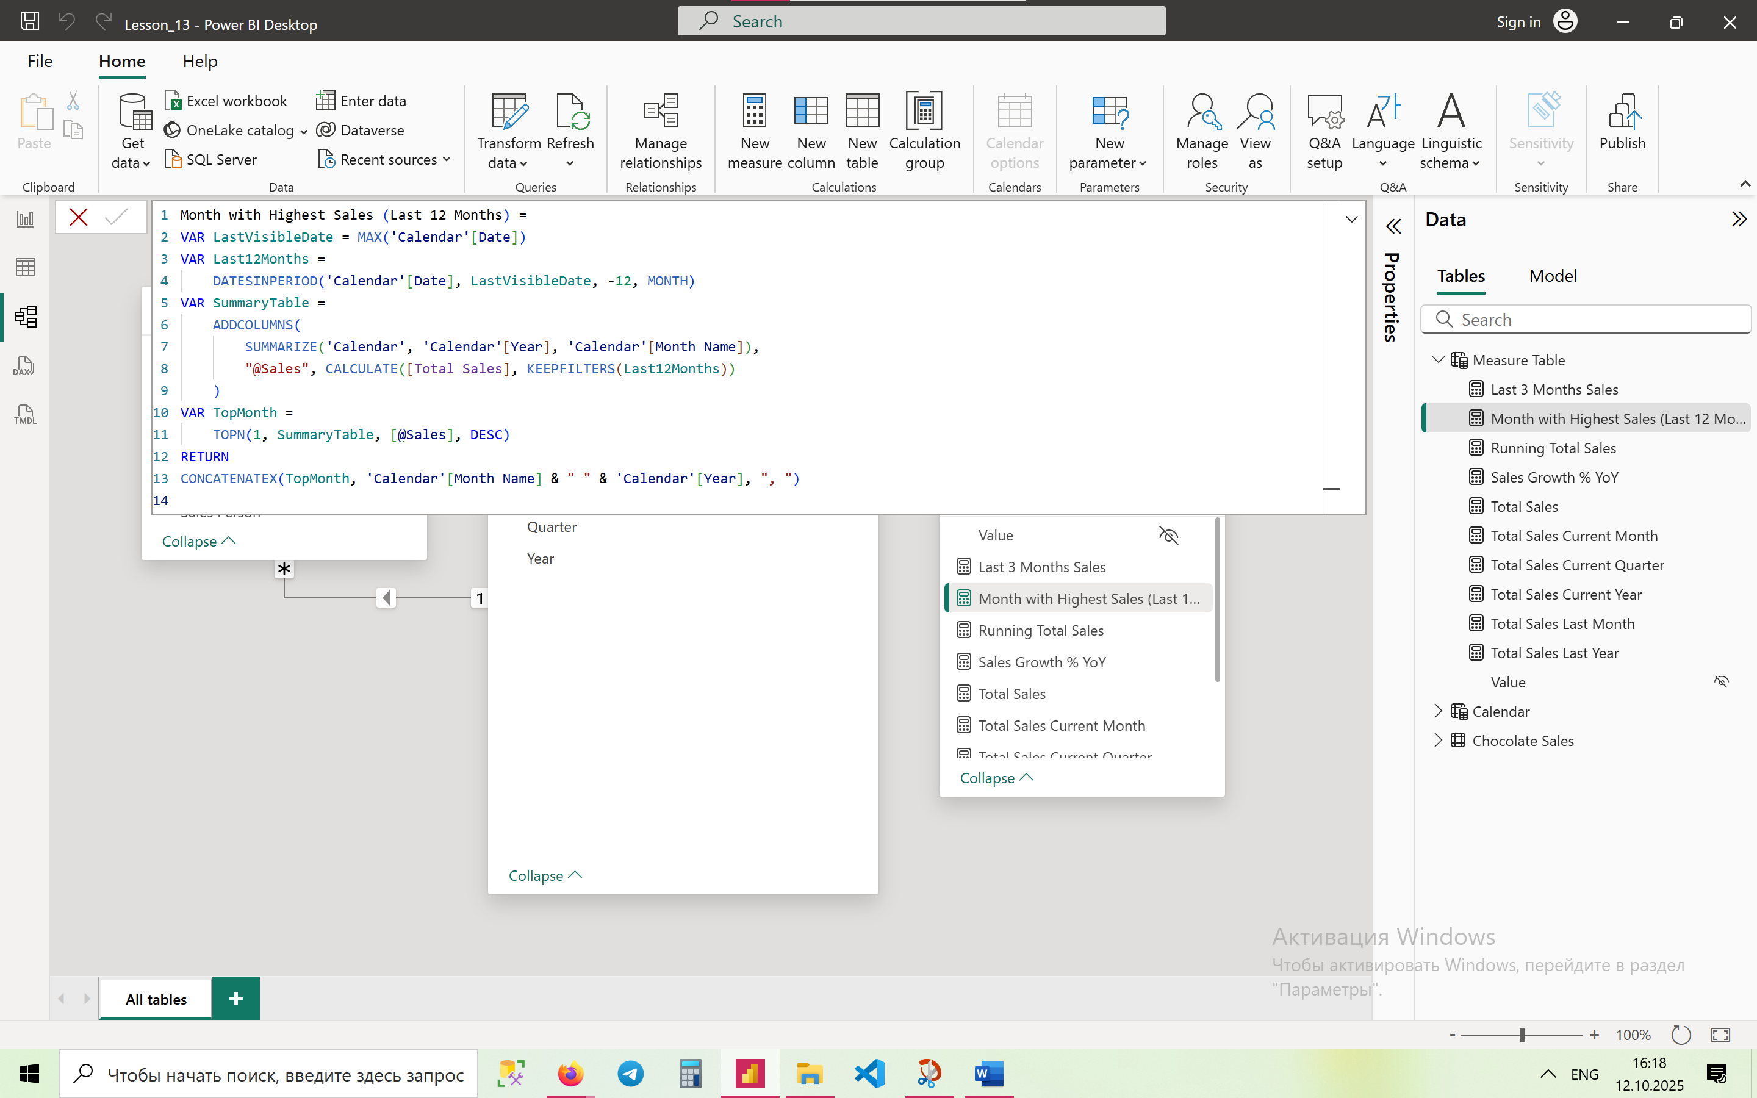

**Advanced (11–15)**

1. Create a measure to compare Q1 Sales of Each Year. Use time intelligence functions with filters to isolate and compare Q1 across years.

**Q1 Sales (Fixed) =**

CALCULATE(

[Total Sales],

FILTER(

ALL('Calendar'),

'Calendar'[Month Number] IN {1, 2, 3}

)

)

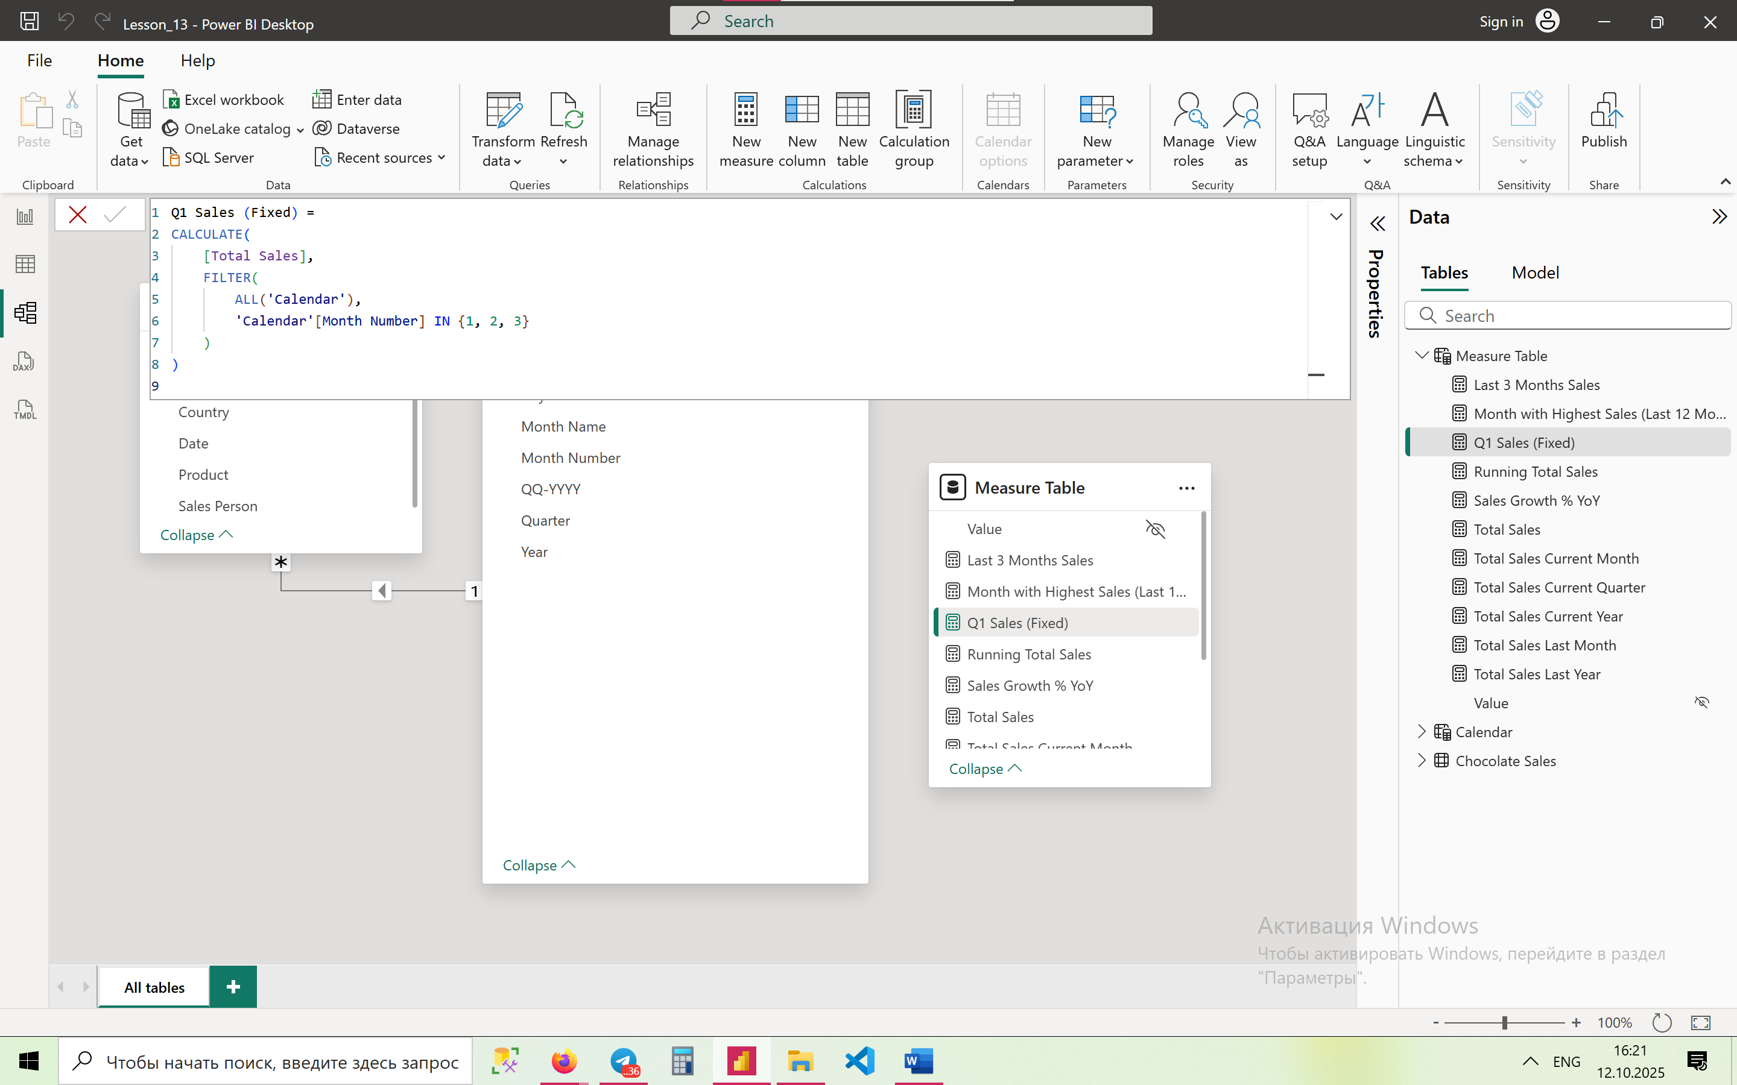

1. Create a measure to Show YoY Difference Only for December.

**December Sales YoY Difference =**

VAR CurrentYear = MAX('Calendar'[Year])

VAR CurrentDec =

CALCULATE(

[Total Sales],

'Calendar'[Year] = CurrentYear,

'Calendar'[Month Number] = 12

)

VAR PreviousDec =

CALCULATE(

[Total Sales],

'Calendar'[Year] = CurrentYear - 1,

'Calendar'[Month Number] = 12

)

RETURN

CurrentDec - PreviousDec

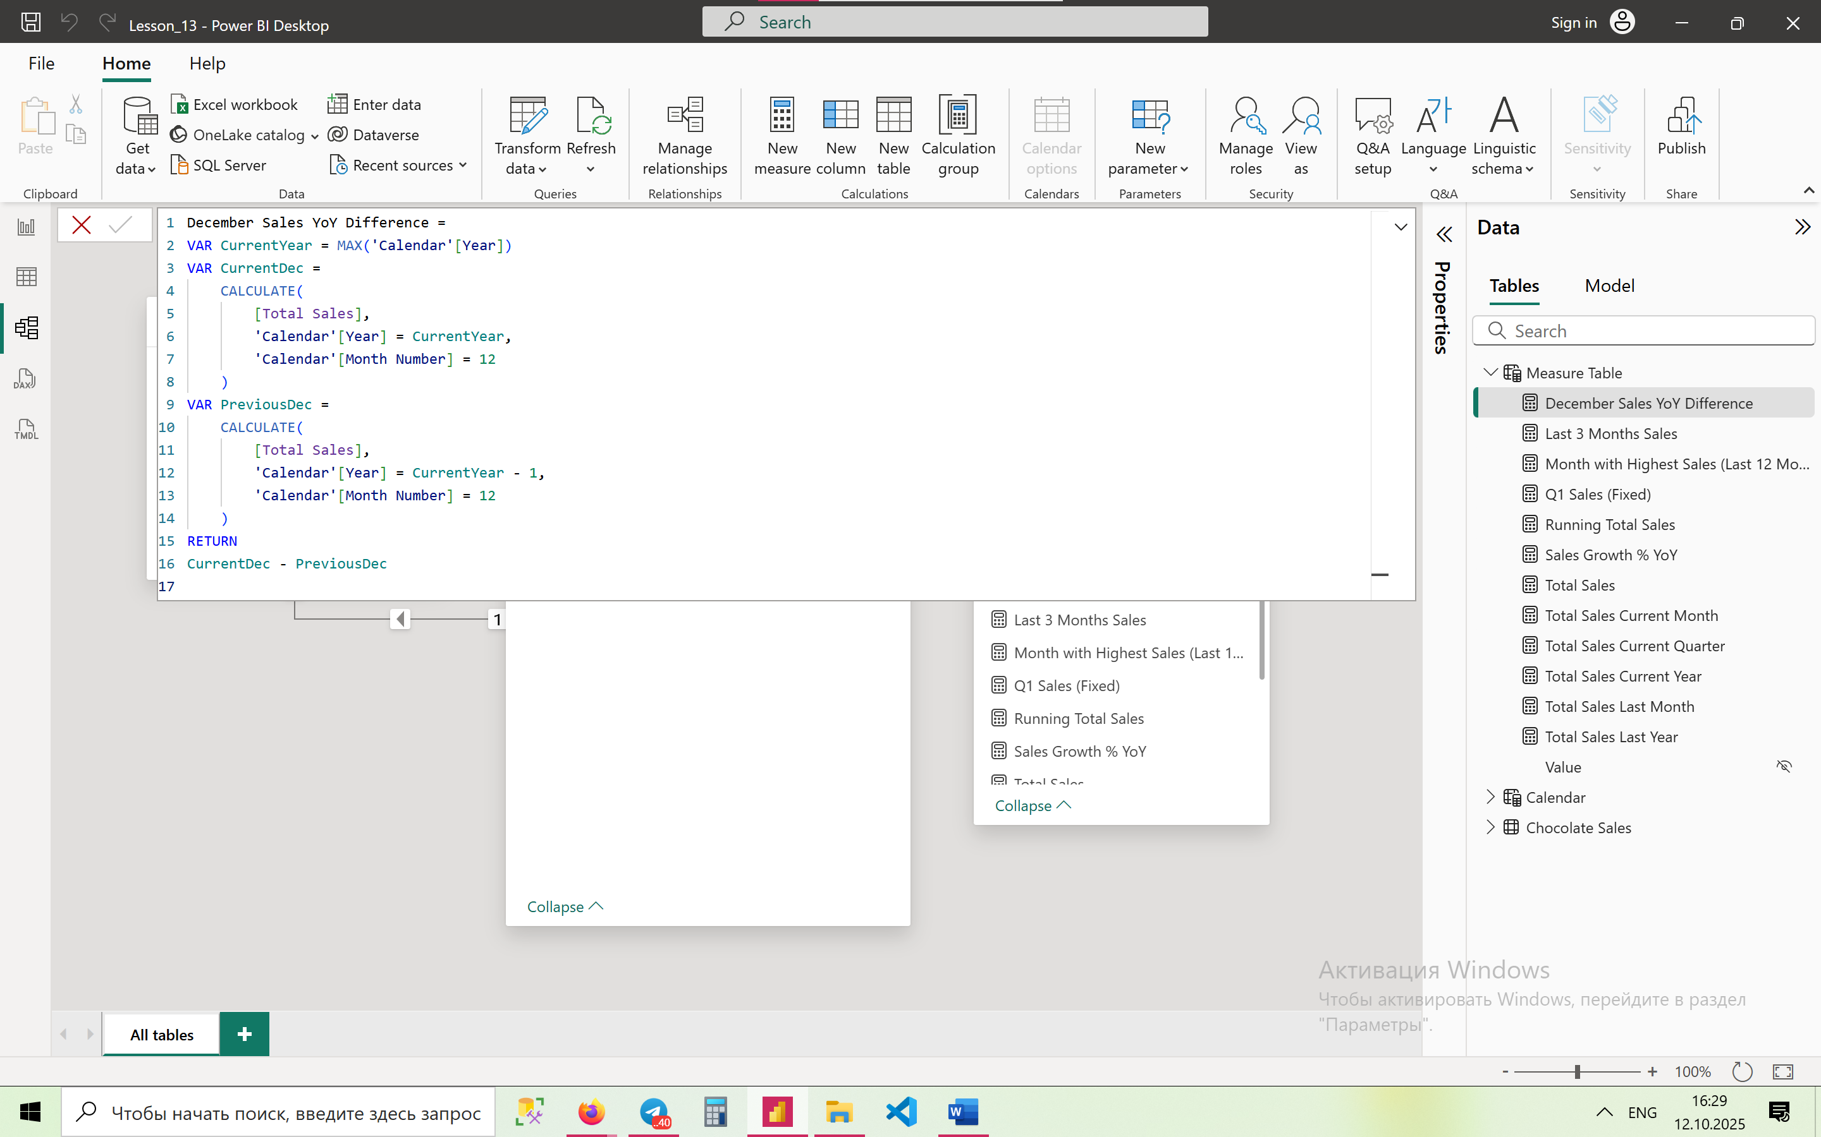

1. Create a measure that sums the last 12 months using.

**Last 12 Months Sales =**

CALCULATE(

[Total Sales],

DATESINPERIOD(

'Calendar'[Date],

MAX('Calendar'[Date]),

-12,

MONTH

)

)

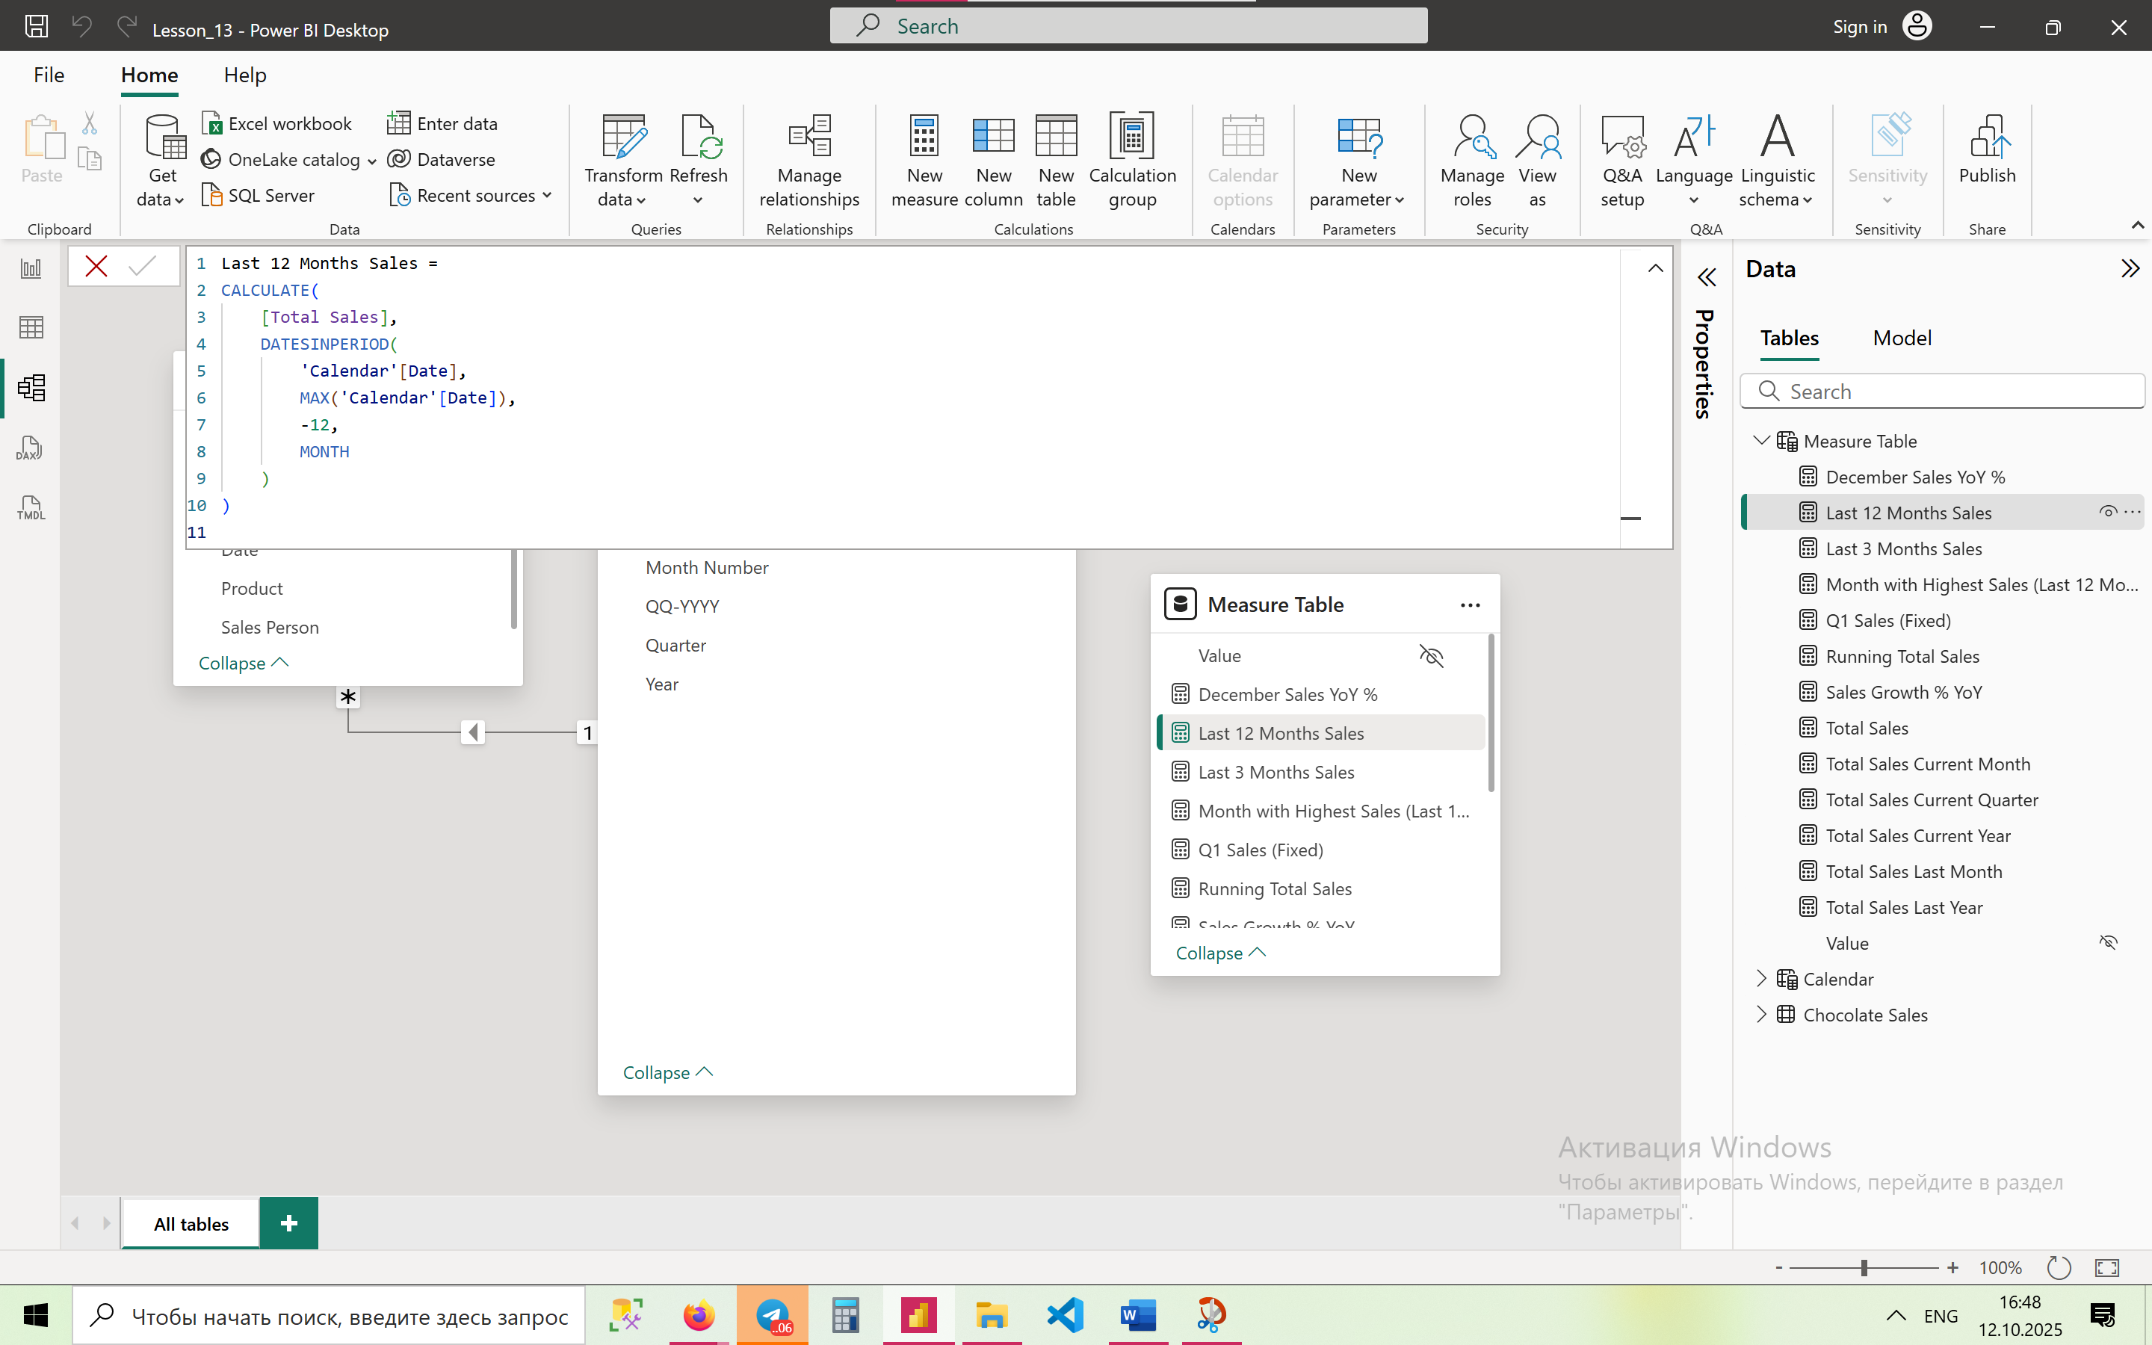

1. Create a measure to identify sales Difference Between Current Quarter and Previous Quarter

**Quarter Sales Difference =**

VAR CurrQtrSales =

CALCULATE(

[Total Sales],

DATESQTD('Calendar'[Date])

)

VAR PrevQtrSales =

CALCULATE(

[Total Sales],

DATEADD('Calendar'[Date], -1, QUARTER)

)

RETURN

CurrQtrSales – PrevQtrSales

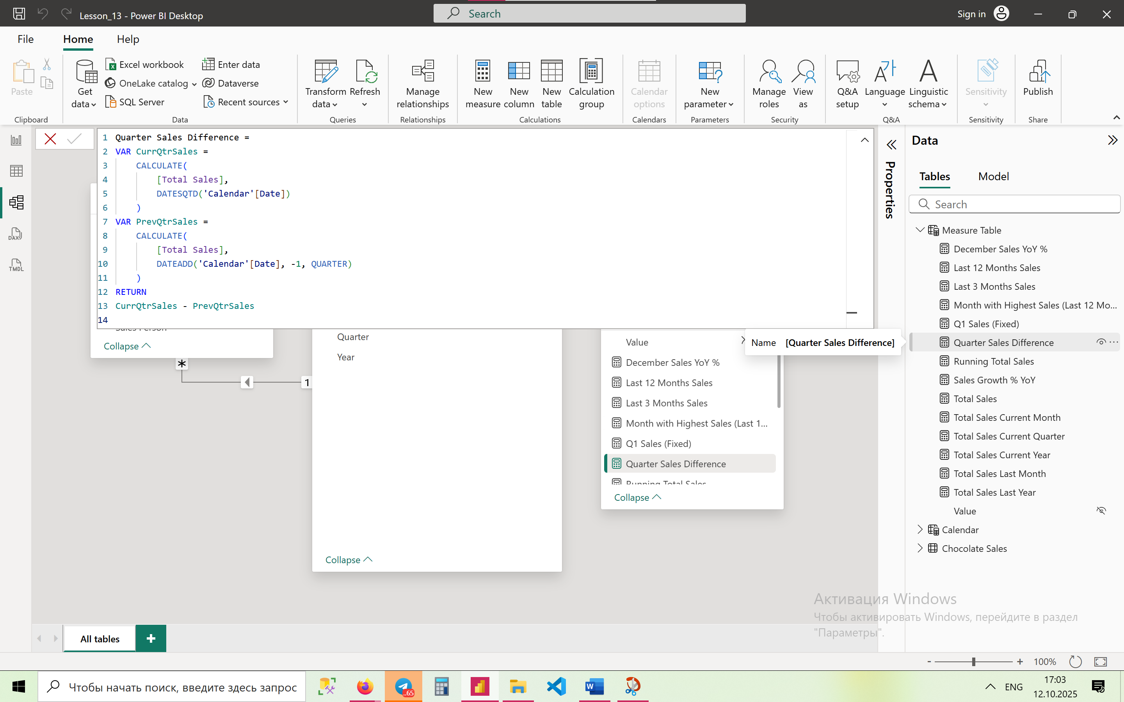

1. Create a measure to highlight Months Where Sales Exceeded Previous Year by 10%+  
   → Compare monthly totals and return a flag when current > 110% of last year.

**Sales Exceeded Last Year by 10%+ =**

VAR CurrMonthSales =

    [Total Sales]

VAR PrevMonthSales =

    CALCULATE(

        [Total Sales],

        SAMEPERIODLASTYEAR('Calendar'[Date])

    )

VAR GrowthRate =

    DIVIDE(CurrMonthSales - PrevMonthSales, PrevMonthSales)

RETURN

IF(GrowthRate > 0.10, "✅ >10% Growth", "❌ Below 10%")

